GROUP ASSIGNMENT
TECHNOLOGY PARK MALAYSIA
CT050-3-2-WAPP
WEB APPLICATIONS
RentSmart KL: A Web-Based Learning System for First-Time Student Renters in Kuala Lumpur
Final Report — Member Module

TABLE OF CONTENTS
1. Introduction 3
1.1 Objectives and scope of the Member module 3
2. Requirement Specification 4
2.1 Use cases 4
2.2 Flow chart: taking a lesson 5
2.3 Major functions 6
3. Design and Modelling 7
3.1 Database tables used by the module 7
3.2 Wireframes 7
3.3 Navigation structure 9
4. Implementation 11
4.1 Shared code and connection to the main system 11
4.2 Member Dashboard (Member/Dashboard.aspx) 12
4.3 Lesson View and red-flag checkpoint (Member/LessonView.aspx) 14
4.4 Pre-signing Checklist (Member/PreSigningChecklist.aspx) 17
4.5 My Progress (Member/MyProgress.aspx) 20
4.6 My Account (Member/MyAccount.aspx) 22
4.7 SQL queries at a glance 24
4.8 Form validation 25
4.9 CSS usage 29
4.10 Testing 30
5. User Guidance: using the Member area 33
6. Conclusion 41
6.1 Summary 41
6.2 Lessons learned 41
6.3 Future enhancements 41
7. References 43

1. Introduction
The Member module of RentSmart KL is the one that registered students who wish to rent can log in to. It allows the members to experience the entire renting process, clear each and every red-flag checkpoint, create their own pre-signing checklist, and get an understanding of how far they have progressed.
Each page is designed to read from and write to RentSmartDB which means that what the member sees is not constant text, but their own information. The pages can only be opened by users whose Session["Role"] is member; the role of admin enables viewing the pages using the Member view.
Page | File | Purpose
Member Dashboard | Member/Dashboard.aspx | Landing page after login: next lesson, journey, checklist preview, progress
Lesson View | Member/LessonView.aspx?id=… | One lesson with video, image, text and the red-flag checkpoint
Pre-signing Checklist | Member/PreSigningChecklist.aspx | The member's own checklist: add, edit, tick and delete items
My Progress | Member/MyProgress.aspx | Every stage with its status and completion date; reset option
My Account | Member/MyAccount.aspx | Change name, email or password; delete the account
Shared code | Member/MemberHelper.cs | Login check, connection string and the journey query used by all five pages

The module uses all five tables in the ERD: Lessons and Checkpoints (read only), Progress (insert, update, delete), ChecklistItems (insert, display, update, delete) and Users (display, update, delete, on My Account).

1.1 Objectives and scope of the Member module
The Member module meets three objectives as stated in our proposal. These objectives are:
- Provide interactive learning through lessons and the ability to assess oneself using red flag checkpoints after each section completes.
- Provide interactive checklist for members to complete before signing the tenancy agreement.
- Provide full data connectivity for all actions in the database [insert, retrieve, update, delete, and authenticate the registered member].
In scope: member’s dashboard, lessons with checkpoints, lesson progress and checklist creation. Out of scope for this module: getting registered and logging into the site (common pages), as well as creating, changing lessons and questions (admin module).

2. Requirement Specification

2.1 Use cases
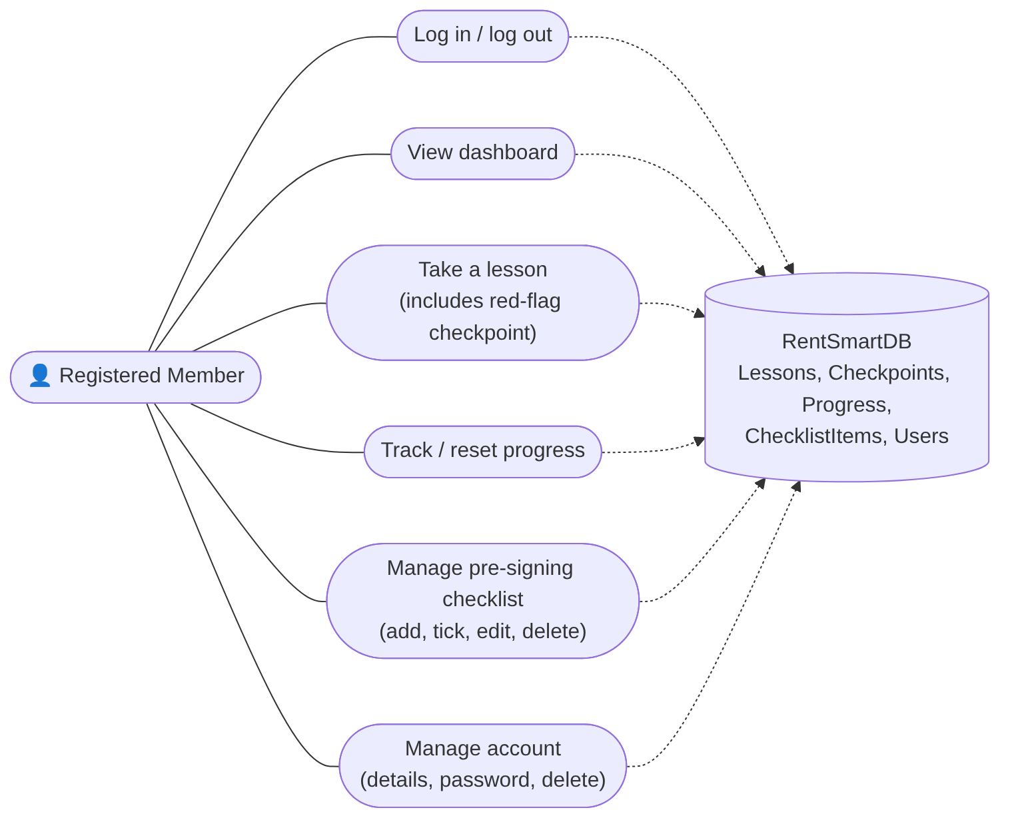
Figure 1: Use case diagram for the registered member
Use case | What the member does | Page | Tables used
Log in / log out | Signs in with email and password; logs out from the menu | Account/Login.aspx (shared) | Users (display)
View dashboard | Sees a greeting, stages done, the next lesson and a checklist preview | Member/Dashboard.aspx | Lessons, Progress, ChecklistItems (display)
Take a lesson | Reads the lesson, watches the video, reads the red-flag box and answers the checkpoint | Member/LessonView.aspx | Lessons, Checkpoints (display); Progress (insert, update)
Track or reset progress | Sees every stage with its status and date; can reset and start again | Member/MyProgress.aspx | Progress (display, delete)
Manage checklist | Adds, ticks, edits and deletes their own pre-signing items | Member/PreSigningChecklist.aspx | ChecklistItems (insert, display, update, delete)
Manage account | Changes name, email or password; deletes the account | Member/MyAccount.aspx | Users (display, update, delete)

2.2 Flow chart: taking a lesson
The main feature of the module is working through a stage and passing its checkpoint. The flow chart shows the checks the page makes and where the progress is saved.
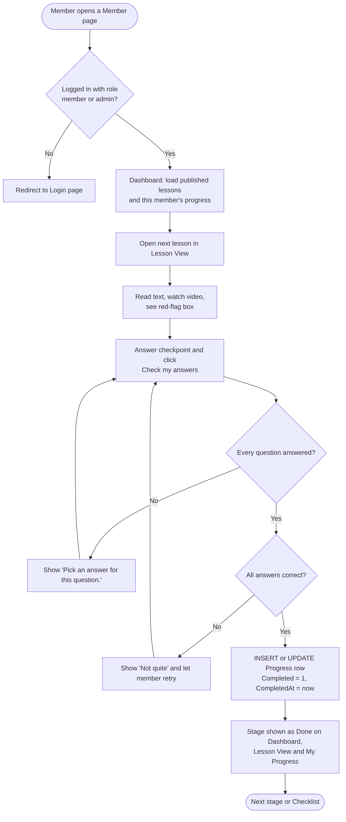
Figure 2: Flow chart of a member taking a lesson and passing its checkpoint

2.3 Major functions
- Member pages can be accessed only by users who are logged in as members or admins; others will see the login page.
- Only lessons with Status = 'published' are displayed in sequential order.
- Stage will save as done only when all the answers in the checkpoints are correct.
- Each query will work only with the member's own records (WHERE UserID = @UserID).
- Form will be verified both in the browser and the server.

3. Design and Modelling

3.1 Database tables used by the module
The module uses the group's shared ERD and database. It does not add or change any tables.
Table | Columns the module uses | Operations
Users | UserID, Name, Email, Password, Role, CreatedAt | Display, Update, Delete
Lessons | LessonID, Title, Content, ImageURL, VideoURL, JourneyStage, Status, RedFlag | Display
Checkpoints | CheckpointID, LessonID, Question, Options, CorrectAnswer | Display
Progress | UserID, LessonID, Completed, CompletedAt | Insert, Display, Update, Delete
ChecklistItems | ItemID, UserID, ItemText, IsChecked | Insert, Display, Update, Delete

3.2 Wireframes
Member pages were developed in accordance with the wireframes created by the group. The layouts of the finalized pages were preserved. Usage of colors and stencils from group design occurred, while two things were incorporated during development, which include red-flag box visible at Lesson View and My Account page.
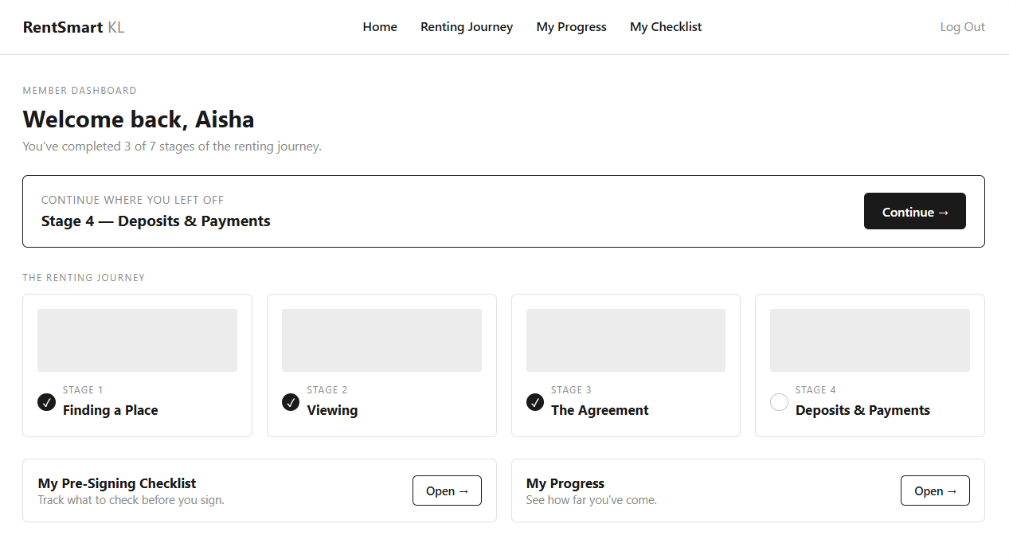
Figure 3: Wireframe – Member Dashboard
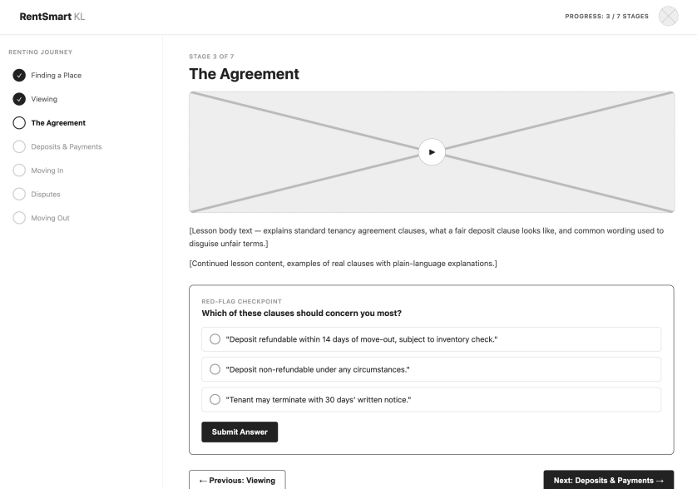
Figure 4: Wireframe – Lesson View with the red-flag checkpoint
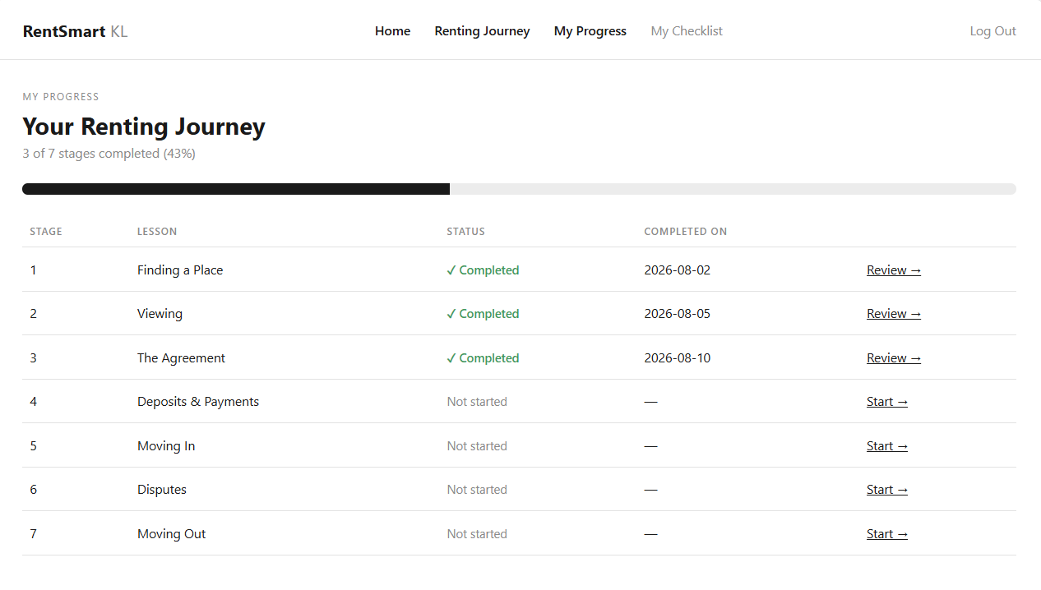
Figure 5: Wireframe – My Progress
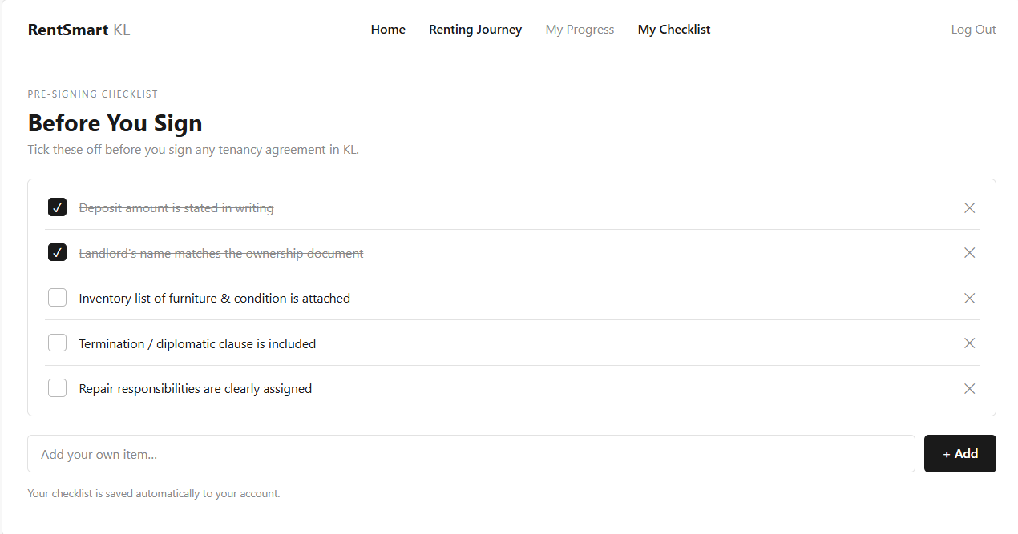
Figure 6: Wireframe – Pre-signing Checklist

3.3 Navigation structure
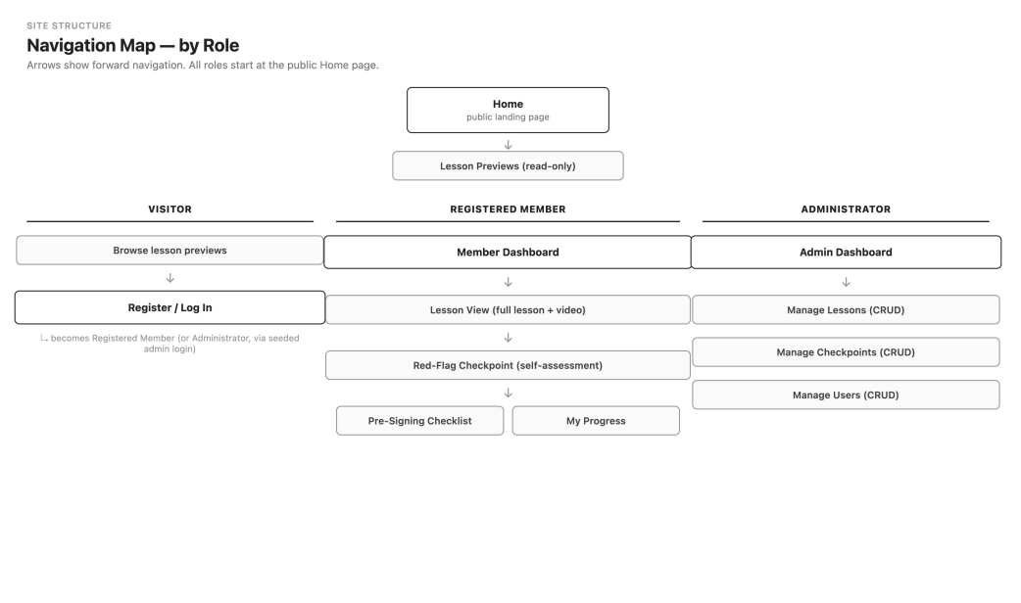
Figure 7: Website navigation map by role (the Registered Member column is this module)
- Dashboard contains links to the next lesson (Continue lesson), the Pre-signing Checklist, My Progress and My Account.
- Lesson View contains a side menu of all the phases plus Previous and Next buttons to enable the user to complete their journey.
- My Progress has a 'Continue' link to the next stage that hasn't yet been completed.
- The Pre-signing Checklist has a 'Back to the lessons' link.
- On each page there is the shared site menu taken from Site.Master (including Log Out)

4. Implementation
This section contains an explanation of the source code of the main Member module features (the shared code used on each page, the SQL, the form validations, the CSS and the testing). Only very small snippets of the code are provided, not the full code.

4.1 Shared code and connection to the main system
All five of the pages in the Member module call the MemberHelper.cs helper class so the login check and the main SQL query are written once and behave exactly the same in every instance.
How it connects to the rest of the site. It doesn't have its own login or database. It simply makes use of the universal login which is provided in Account/Login.aspx. Once the user has logged in it will store Session["UserID"], Session["Name"] and Session["Role"] in the session. It connects to the shared database via the RentSmartConnection in web.config.
Authorization check. The RequireMember method is called at the top of Page_Load on all Member pages. If the user is not logged in or is logged in without member or admin privileges they are redirected to the login page prior to any member information being loaded. It is worth noting that admin access is permitted in order to see how the Member link appears in the Admin panel, even though there is no option available to an admin to delete a user account from the My Account module (Section 4.6).
public static int RequireMember(Page page)
{
string role = page.Session["Role"] as string;
string idText = page.Session["UserID"] as string;

int userId;
bool hasId = int.TryParse(idText, out userId);

// Members, and admins using the "Member view" link, may open member pages.
bool allowed = role != null &&
(role.Equals("member", StringComparison.OrdinalIgnoreCase) ||
role.Equals("admin", StringComparison.OrdinalIgnoreCase));

if (!hasId || !allowed)
{
page.Response.Redirect("~/Account/Login.aspx");
}
return userId;
}
This method returns UserID of any member. Every subsequent query in the module is filtered with WHERE UserID = UserID parameter so that the member can view and modify information only for himself.
Caching is disallowed in RequireMember method. In other words, RequireMember instructs the browser not to cache any information about members. The reason for this is that if the member quits the page, goes to previous one and presses Back, he will see the information from the previous page.
page.Response.Cache.SetCacheability(HttpCacheability.NoCache);
page.Response.Cache.SetNoStore();
page.Response.Cache.SetExpires(DateTime.UtcNow.AddMinutes(-1));
Because it sits in the shared helper, all five Member pages get it with one change.
The journey query (SELECT). The Dashboard, Lesson View and My Progress pages all need the list of lessons together with this member's progress, so the query lives in GetJourney:
SELECT L.LessonID, L.Title, P.Done, P.CompletedAt
FROM Lessons L
LEFT JOIN (SELECT LessonID,
MAX(CAST(Completed AS INT)) AS Done,
MAX(CompletedAt) AS CompletedAt
FROM Progress
WHERE UserID = @UserID
GROUP BY LessonID) P ON P.LessonID = L.LessonID
WHERE L.Status = 'published'
ORDER BY TRY_CAST(L.JourneyStage AS INT), L.LessonID

The LEFT JOIN ignores lessons the member hasn’t yet begun because these lessons lack a progress row. Lessons appear in the order of their journey stage numbers. In C#, the first unfinished lesson is set as next, and the remaining lessons are marked todo; the web pages use these terms when coloring according to stages of the journey.

Published lessons only. The admin can save a lesson as a draft while working on it. But only published lessons have status=’published’ and are available to learners. The WHERE L.Status = ‘published’ command hides drafts from all member pages immediately because all of them rely on this query to create their lessons’ lists. A progress record for a lesson that will later be set back to draft is preserved in the database, but this lesson won’t be shown or counted while it’s a draft.

Parameterized queries. This means that every parameter received from a user session is used as a parameter (@UserID, @LessonID, @ItemText) and doesn’t go directly into SQL text. This protects the database from SQL injection.

4.2 Member Dashboard (Member/Dashboard.aspx)
The Dashboard is the member's landing page after login. Everything on it is built from the database when the page loads.
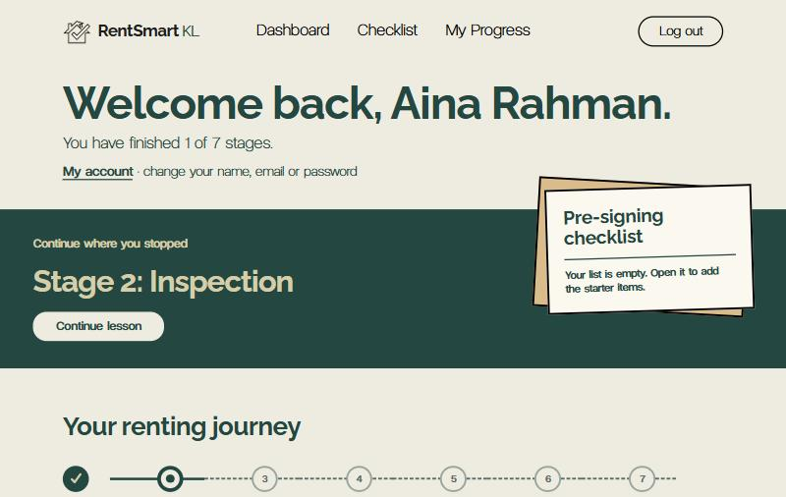
Figure 8: Member Dashboard after login: welcome line, stage count and the "Continue where you stopped" band
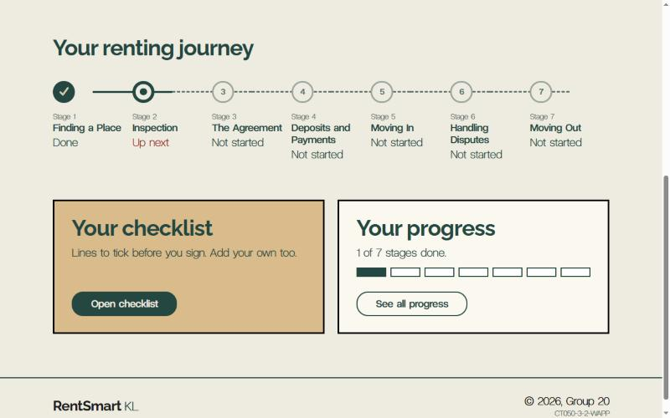
Figure 9: Dashboard journey list: Stage 1 Done, Stage 2 Up next, the rest Not started
What it shows and where the data comes from
- Greeting: member's name from Session["Name"], set at login.
- Summary and progress bar: number of lessons completed and total lessons, based on the query in Section 4.1.
- First lesson where the member left off: the first lesson the member has not passed, with a button to open it. If the member completed all lessons, "Journey complete" will appear.
- Member's learning journey: one object for each lesson, marked Done, Up next, or Not started. This is an ASP.NET Repeater controlled by the journey’s list.
- Checklist preview: the first three items from the member's checklist, with the number of ticked items.
- Key code. The journey is loaded only once, on the first page view (!IsPostBack). Then it determines which band to show.
Key code. The journey is loaded only once, on the first page view (!IsPostBack). Then it determines the type of the band to show.
List<LessonStatus> journey = MemberHelper.GetJourney(userId);
int total = journey.Count;
int done = journey.FindAll(l => l.IsDone).Count;
LessonStatus next = journey.Find(l => l.State == "next");

if (next == null)
{
phNext.Visible = false; // nothing left to do
phAllDone.Visible = true; // show "Journey complete"
}
else
{
lnkContinue.NavigateUrl = "~/Member/LessonView.aspx?id=" + next.LessonID;
}

rptJourney.DataSource = journey;
rptJourney.DataBind();
SQL used (Display)
Checklist preview, the member's first three items:
SELECT TOP 3 ItemText, ISNULL(IsChecked, 0) AS IsChecked
FROM ChecklistItems
WHERE UserID = @UserID
ORDER BY ItemID
Ticked count for the preview:
SELECT COUNT(*) AS Total,
ISNULL(SUM(CASE WHEN IsChecked = 1 THEN 1 ELSE 0 END), 0) AS Ticked
FROM ChecklistItems
WHERE UserID = @UserID
The journey itself uses the shared GetJourney query from Section 4.1.

4.3 Lesson View and red-flag checkpoint (Member/LessonView.aspx)
Lesson View shows one lesson, chosen by ?id= in the address, and saves the stage as completed when the member passes its checkpoint. If no id, a wrong id, or the id of a draft lesson is given, the page opens the member's next unfinished published lesson instead, so a draft can never be read by typing its number into the address bar.
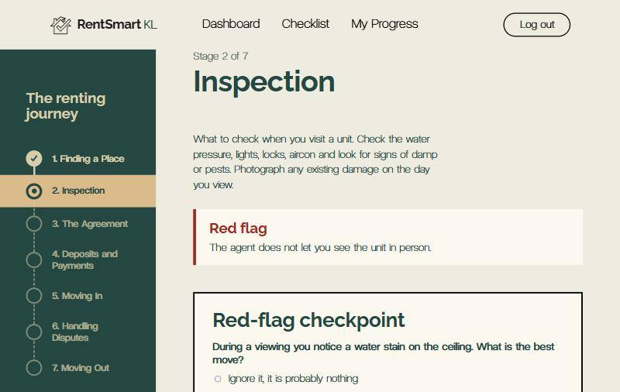
Figure 10: Lesson View: the side list of stages (Stage 1 ticked, Stage 2 current) and the start of the lesson
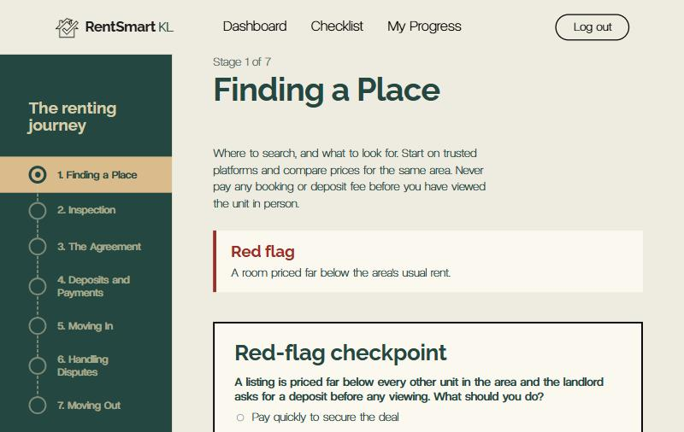
Figure 11: Lesson text followed by the red-flag box and the checkpoint
Lesson content and multimedia. The title, text, image and video come from the Lessons table:
SELECT Title, Content, ImageURL, VideoURL, RedFlag
FROM Lessons
WHERE LessonID = @LessonID AND Status = 'published'
When the VideoURL is a link to a YouTube video, the page incorporates an embedded YouTube player (<iframe>); if it is a video file, then the HTML5 <video controls> element is used. The lesson text is first passed through HtmlEncode before it is displayed, which ensures that any HTML stored in the database appears as plain text and does not execute in the browser.
Since AND Status = 'published' is an additional check on the journey list, this query will never return a draft even if the query is invoked directly.
Red-flag box. For example, whenever there is a warning sign such as asking for payment to be made into a private bank account, the lesson includes a section devoted to it titled RedFlag. The lesson text then appears next to the slip in the design team's red box when the RedFlag section has been completed. The entire text is HTML encoded and the box remains hidden in every lesson that does not have a RedFlag:
string redFlag = reader["RedFlag"] == DBNull.Value ? "" : reader["RedFlag"].ToString().Trim();
if (redFlag.Length > 0)
{
// Start with a capital letter, whatever was typed in the admin form
redFlag = char.ToUpper(redFlag[0]) + redFlag.Substring(1);
litRedFlag.Text = HttpUtility.HtmlEncode(redFlag);
phRedFlag.Visible = true;
}
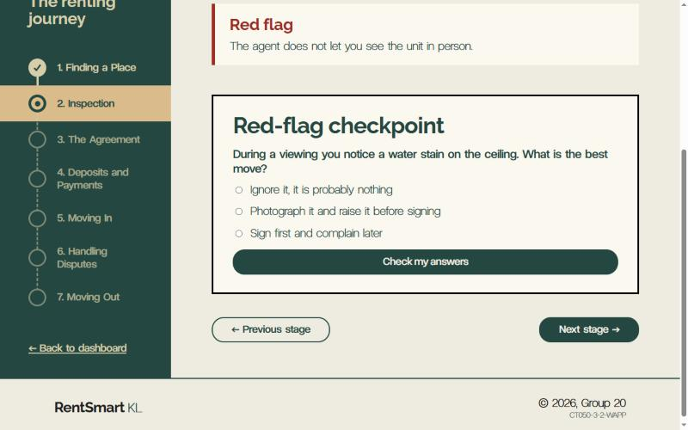
Figure 12: The red-flag box for this lesson, shown just above the checkpoint
Loading the checkpoint. This is taken from the Checkpoints table. The correct answer is purposely not selected here, and so cannot be viewed in the browser from "View source":
SELECT CheckpointID, Question, Options
FROM Checkpoints
WHERE LessonID = @LessonID
ORDER BY CheckpointID
Each question is a RadioButtonList. The options are stored in a single text column and are divided by vertical bars "|". During binding of each question, the Processing Code will parse and convert them into radio buttons.
Checking the answers. When the member clicks Check my answers, the server will read the correct answers and compare them with what was clicked:

foreach (RepeaterItem item in rptCheckpoints.Items)
{
HiddenField idField = (HiddenField)item.FindControl("hfCheckpointID");
RadioButtonList options = (RadioButtonList)item.FindControl("rblOptions");

int checkpointId = Convert.ToInt32(idField.Value);
bool isRight = correctAnswers.ContainsKey(checkpointId)
&& IsCorrect(options.SelectedValue, options.SelectedIndex, correctAnswers[checkpointId]);
// each question then shows "Correct." or "Not quite..."
}
Each question shows its own feedback. Only when every answer is correct is the lesson marked as complete.
Saving progress (Insert or Update). MarkLessonComplete first checks to see whether this member already has a Progress row for the lesson:
SELECT COUNT(*) FROM Progress
WHERE UserID = @UserID AND LessonID = @LessonID
If there is no row, it inserts one:
INSERT INTO Progress (UserID, LessonID, Completed, CompletedAt)
VALUES (@UserID, @LessonID, 1, @CompletedAt)
If a row exists (for example, after a reset), it updates it. The Completed = 0 condition keeps the original completion date if the member retakes a finished checkpoint:
UPDATE Progress SET Completed = 1, CompletedAt = @CompletedAt
WHERE UserID = @UserID AND LessonID = @LessonID
AND (Completed = 0 OR Completed IS NULL)
In a lesson without any checkpoint questions, a button with the label Mark this stage as done is present, which completes the saving process. For navigation, a list on the side panel shows all stages (done, current, or to do), whereas the buttons Previous and Next help to navigate through the journey.

4.4 Pre-signing Checklist (Member/PreSigningChecklist.aspx)
The checklist is a personal record created by a member containing all the tasks that the member must accomplish before signing a lease. It performs all four operations of the database – insertion, display, updating, and deletion of information from the table ChecklistItems.
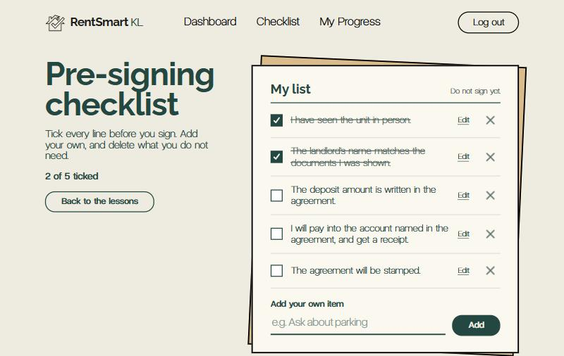
Figure 13: Checklist with two items ticked (crossed out) and the count "2 of 5 ticked"
Display (SELECT). When the page opens, it loads only this member's items:
SELECT ItemID, ItemText, ISNULL(IsChecked, 0) AS IsChecked
FROM ChecklistItems
WHERE UserID = @UserID
ORDER BY ItemID
The repeater is bound to each row in the item list. A tick button and a delete button are present on every row along with the item's ID as the CommandArgument for those buttons. The page sends an additional indication of the number of ticked items out of the total number of items and a message like "Do not sign yet." Insert (add your own item). After the validation process (see Section 4.8), the entered text is recorded:
INSERT INTO ChecklistItems (UserID, ItemText, IsChecked)
VALUES (@UserID, @ItemText, 0)
The new user will have an empty list, which means that the page will offer to Add the initial list. This will execute INSERT five times, using one command and just varying @ItemText. Update (tick/untick) and Delete. Both buttons are directing the command to one handler rptItems_ItemCommand, which is performing the SQL according the command name.
if (e.CommandName == "Toggle")
{
// UPDATE: flip the tick (1 becomes 0, 0 becomes 1)
sql = "UPDATE ChecklistItems SET IsChecked = CASE WHEN IsChecked = 1 THEN 0 ELSE 1 END " +
"WHERE ItemID = @ItemID AND UserID = @UserID";
}
else if (e.CommandName == "Remove")
{
// DELETE: remove the item
sql = "DELETE FROM ChecklistItems WHERE ItemID = @ItemID AND UserID = @UserID";
}
The two queries contain AND UserID = @UserID. Even if someone attempts to change the ItemID, they can’t check or erase someone else's item. The browser will prompt the user before proceeding with deletion.
Update (edit the text). Moreover, an item has the Edit option. The user can click on it and the item would get loaded into the textbox. The ItemID is saved in ViewState, but it won’t be a hidden field that could have been modified by a user.
SELECT ItemText FROM ChecklistItems WHERE ItemID = @ItemID AND UserID = @UserID
Save runs the same validation as Add (required, 3 to 120 characters) and then updates only that member's item:
UPDATE ChecklistItems SET ItemText = @ItemText WHERE ItemID = @ItemID AND UserID = @UserID
In case nothing was altered in the database (the item could be deleted in another tab or it’s not the item of this user), the website would display a message “That item could not be found.” instead of pretending that the operation was successful. Input validation: If ASP.NET does not limit the input and a user tries to write <, they will get an error page. In our case, both input boxes have ValidateRequestMode="Disabled" value. It is still secure though as any text is written into the database using SQL parameters and inserted back into the page using <%#: %>, which allows encoding text and replacing any special characters.
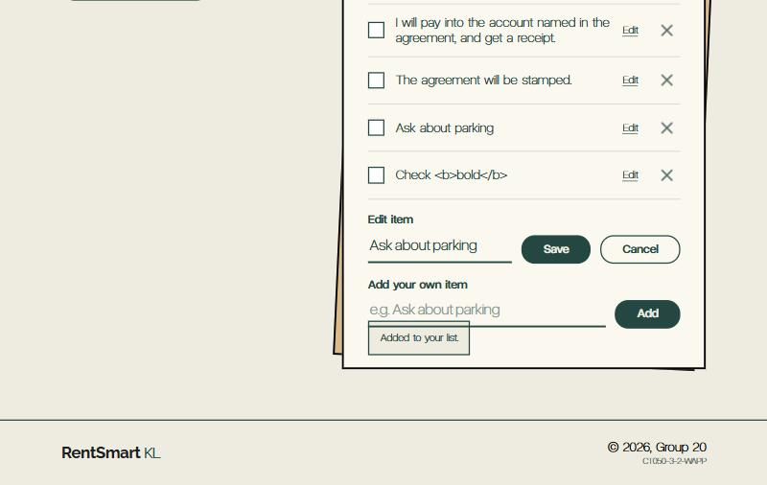
Figure 14: An item open in the Edit box with Save and Cancel
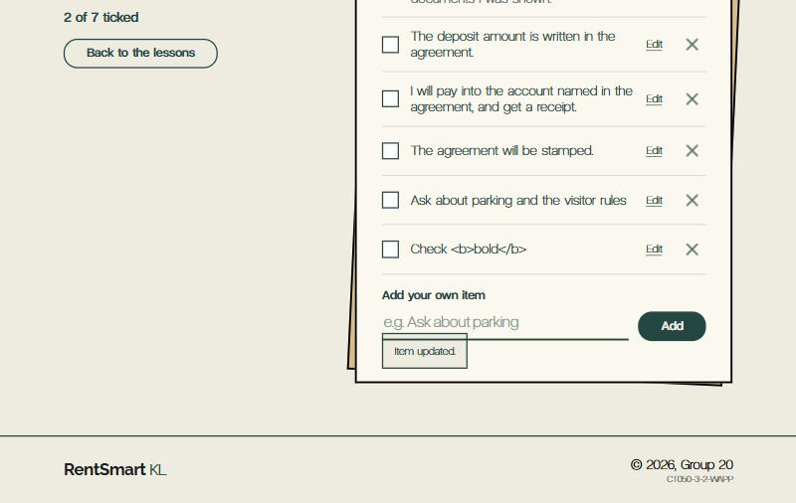
Figure 15: After Save: the new text in the list and the message "Item updated."
After every change, the page reloads the list from the database, so the screen always matches what is stored.

4.5 My Progress (Member/MyProgress.aspx)
The page My Progress includes information about every stage’s status and date the stage was completed by the member.

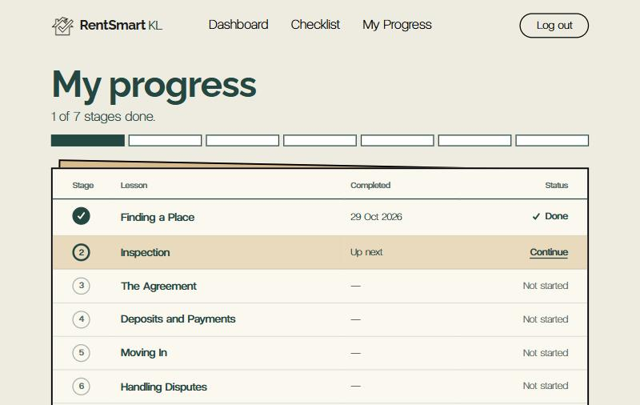
Figure 16: My Progress: Stage 1 Done with its date, Stage 2 Up next with a Continue link
Display. This page uses a shared journey query (see Section 4.1) and connects the data to the Repeater to form a table with rows for lessons. The data service uses helper methods for every table cell content.
protected string CompletedText(object dataItem)
{
LessonStatus lesson = (LessonStatus)dataItem;
if (lesson.IsDone && lesson.CompletedAt.HasValue)
return lesson.CompletedAt.Value.ToString("d MMM yyyy");
if (lesson.State == "next") return "Up next";
return "&mdash;";
}
As for the unfinished stage, it contains a Continue link for the upcoming stage. The table has the attribute data-label added to every cell. It is a phone-friendly version of the table where every row is transformed into a card.
The progress bar. There is a row of boxes that displays the whole number of lessons by filling those with completed ones. All the boxes are added to the inline style of the element. Delete / reset progress. The option Reset my progress gets visible only when there is at least one completed stage; after the user accepts it, all progress records are deleted.
DELETE FROM Progress WHERE UserID = @UserID
The table then reloads with every stage back to "Not started". Only this member's rows are removed; other members' progress is not touched.

4.6 My Account (Member/MyAccount.aspx)
In My Account, it is possible for a member to control their own row in the Users table: to modify their name and email address, or to change their password or remove the account altogether. Its link can be found in the Dashboard ("My account · change name, email or password").
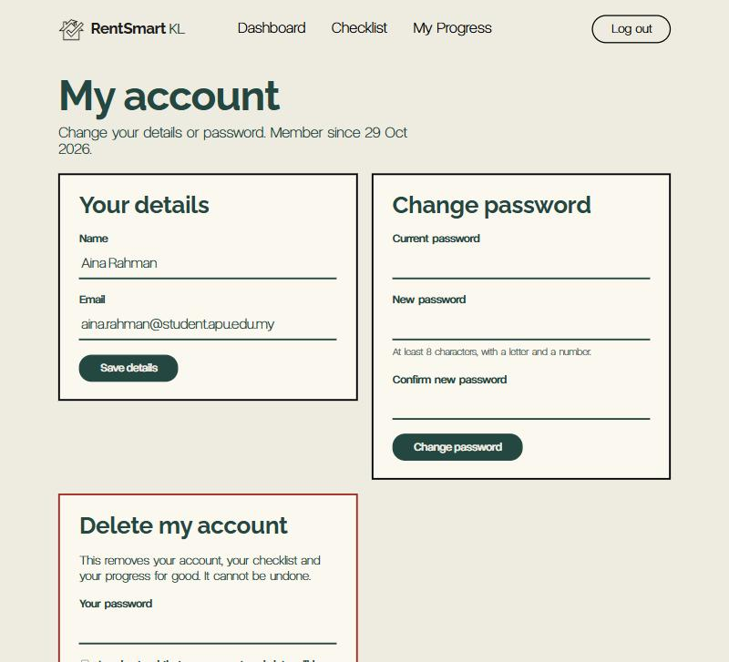
Figure 17: My Account with its three cards: Your details, Change password and Delete my account
Display (SELECT). On first load the form is filled from the database:
SELECT Name, Email, CreatedAt FROM Users WHERE UserID = @UserID
The CreatedAt field is displayed in the title of the application as "Member since 16 Oct 2026". Change name and email (UPDATE). The email must initially not belong to any other account. A CustomValidator on the server guarantees this; the expression UserID <> @UserID excludes the row of the member themselves from the check.
SELECT COUNT(*) FROM Users WHERE Email = @Email AND UserID <> @UserID
Once all validators have passed, the row in the database is updated, and in Session["Name"] the variable is also updated to the new value, which means that the Dashboard will display the new name to the member immediately.
UPDATE Users SET Name = @Name, Email = @Email WHERE UserID = @UserID
Change password (UPDATE). The current password is verified first. The page retrieves the stored password, which is compared in C# (using the StringComparison.Ordinal type of comparison). This is needed since SQL Server performs case-insensitive comparisons.
SqlCommand cmd = new SqlCommand("SELECT Password FROM Users WHERE UserID = @UserID", con);
cmd.Parameters.AddWithValue("@UserID", userId);
object stored = cmd.ExecuteScalar();
return string.Equals(stored.ToString().TrimEnd(), typed.TrimEnd(), StringComparison.Ordinal);
The new password is then saved the same way Register.aspx stores it, so Login.aspx keeps working:
UPDATE Users SET Password = @Password WHERE UserID = @UserID
Delete the account (DELETE). In this database deletion operation, the ON DELETE CASCADE restriction is not enabled meaning that when deleting the rows of a user’s children, the row referring to this user is deleted last. All three of these deletions take place in one SqlTransaction, meaning that any failure of any of those deletions will lead to a rollback and will prevent a situation where the database is only half deleted.
SqlTransaction tx = con.BeginTransaction();
string[] steps =
{
"DELETE FROM ChecklistItems WHERE UserID = @UserID",
"DELETE FROM Progress WHERE UserID = @UserID",
"DELETE FROM Users WHERE UserID = @UserID AND Role = 'member'"
};
foreach (string sql in steps)
{
SqlCommand cmd = new SqlCommand(sql, con, tx);
cmd.Parameters.AddWithValue("@UserID", userId);
cmd.ExecuteNonQuery();
}
tx.Commit();
If an account still has some connections to a lesson (lessons created by certain users only), deletion will not be permitted and the user will not receive an error message but a user-friendly notification. If deletion took place successfully, a user session is cleared and the user is redirected to the account login page. Deleting an account requires typing in the correct password, marking the “I understand” checkbox, and confirming the deletion through a pop-up box. Admin users will see the information “Admin accounts cannot be deleted here,” as well as an additional condition present in the last SQL statement, i.e., AND Role = ‘member.’
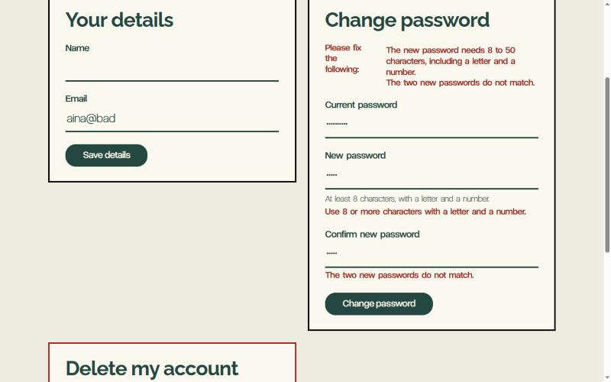
Figure 18: Change password card: the error summary when the new password is too short and the two new passwords do not match

4.7 SQL queries at a glance
The Member module carries out all four required operations: Insert, Display, Update and Delete. Every query is parameterised and limited to the logged-in member's UserID.
Operation | Page | Table | What it does
Display | All pages (MemberHelper.GetJourney) | Lessons + Progress | Lists lessons in journey order with this member's completion status
Display | Dashboard | ChecklistItems | First three checklist items and the ticked count
Display | Lesson View | Lessons | One lesson's title, text, image and video
Display | Lesson View | Checkpoints | Questions and options (without the correct answer)
Insert | Lesson View | Progress | Saves a stage as completed the first time it is passed
Update | Lesson View | Progress | Marks an existing Progress row as completed
Insert | Pre-signing Checklist | ChecklistItems | Adds the member's own item, or the five starter items
Display | Pre-signing Checklist | ChecklistItems | Lists this member's items
Update | Pre-signing Checklist | ChecklistItems | Ticks or unticks an item
Delete | Pre-signing Checklist | ChecklistItems | Removes an item
Delete | My Progress | Progress | Resets all of this member's progress
Update | Pre-signing Checklist | ChecklistItems | Changes the text of one item (Edit)
Display | My Account | Users | Shows the member's name, email and join date; checks the email is not taken
Update | My Account | Users | Changes name and email, or the password
Delete | My Account | ChecklistItems, Progress, Users | Deletes the account, child rows first, in one transaction

4.8 Form validation
There are two types of forms contained in the Member module: The Add your own item form of the checklist and the lesson checkpoint. Each of them utilizes ASP.NET validator controls. This means that the input undergoes two checks: first within the browser and then on the server.
Checklist item. The add validation group contains two validators. One of them validates if the text box is empty, while the other one validates if the value is within 3 and 120 characters.
<asp:RequiredFieldValidator ID="rfvItem" runat="server" ControlToValidate="txtItem"
ValidationGroup="add" CssClass="error" Display="Dynamic"
ErrorMessage="Type an item first." />
<asp:RegularExpressionValidator ID="revItem" runat="server" ControlToValidate="txtItem"
ValidationGroup="add" CssClass="error" Display="Dynamic"
ValidationExpression="^[\s\S]{3,120}$"
ErrorMessage="The item must be 3 to 120 characters long." />
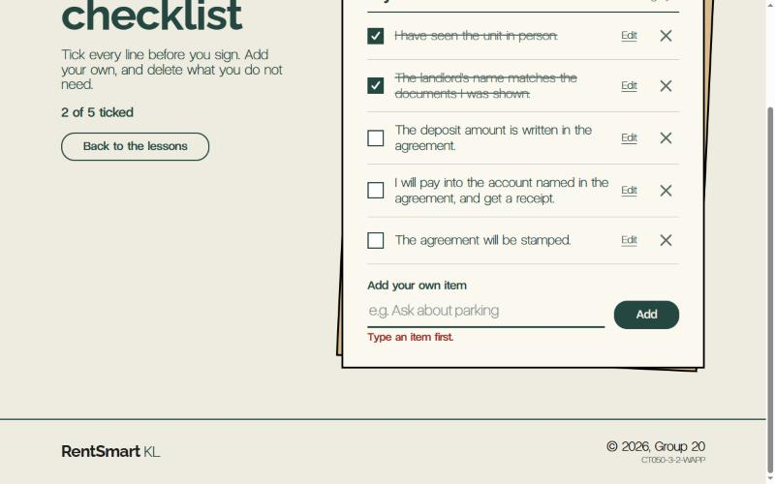
Figure 19: "Type an item first." under the empty box after clicking Add
Checkpoint. In the checkpoint group, every question features a RequiredFieldValidator that makes sure that every question is answered before the user can proceed with submitting his or her answers.
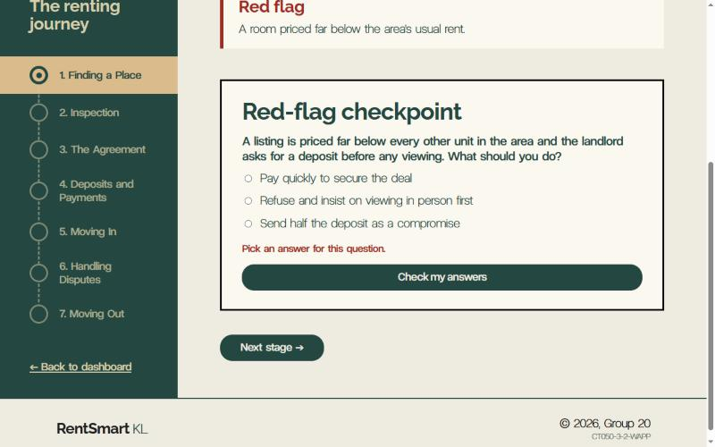
Figure 20: "Pick an answer for this question." under an unanswered question
Server-side checks. Browser checks may be disabled, which means that each button's callback still checks the input before changing the database.
string text = txtItem.Text.Trim();
if (!Page.IsValid || text.Length < 3 || text.Length > 120)
{
ShowMessage("The item must be 3 to 120 characters long.", false);
return;
}
The two validation groups (add and checkpoint) maintain the distinction between the forms so that clicking on the Tick or Delete buttons in the checklist doesn’t activate the add-item validators. This is because they specify CausesValidation="false."
Edit box (checklist). The edit box has its own edit validation group with the same Required and 3-120 character rules as Add, therefore a half-typed new item will never stop a save.
My Account. This page uses the full range of ASP.NET validators. Every form has a different validation group and a ValidationSummary that lists all errors right on top of the card and each validator provides its own short message under its field.
Validator | Field | Rule
RequiredFieldValidator | Name, Email, every password box | Cannot be empty
RegularExpressionValidator | Name | ^[A-Za-z][A-Za-z .'@/\-]{1,49}$: letters, spaces and . ' - / @, 2 to 50 characters (allows "Ali bin Abu")
RegularExpressionValidator | Email | Must look like name@example.com
CustomValidator (server) | Email | No other account may use it (SELECT COUNT(*) … AND UserID <> @UserID)
CustomValidator (server) | Current password, Delete password | Must match the stored password exactly (case-sensitive)
RegularExpressionValidator | New password | ^(?=.*[A-Za-z])(?=.*\d).{8,50}$: 8 to 50 characters with at least one letter and one number
CompareValidator, Operator="NotEqual" | New password | Must be different from the current password
CompareValidator, Operator="Equal" | Confirm new password | Must match the new password
CustomValidator (client + server) | "I understand" checkbox | Must be ticked; a CheckBox cannot use RequiredFieldValidator, so a JavaScript function rskUnderstandTicked checks it in the browser and cvUnderstand_ServerValidate checks it again on the server
ValidationSummary | Each of the three cards | Lists every error of that card under "Please fix the following:"

Every button handler begins with if (!Page.IsValid) return; therefore all those rules are re-evaluated on server side as well, regardless of JavaScript being disabled.
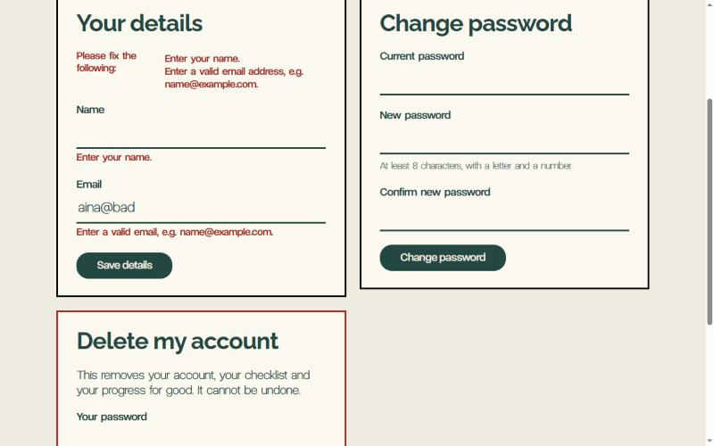
Figure 21: Your details: the ValidationSummary lists both problems (empty name, bad email) and each field shows its own message
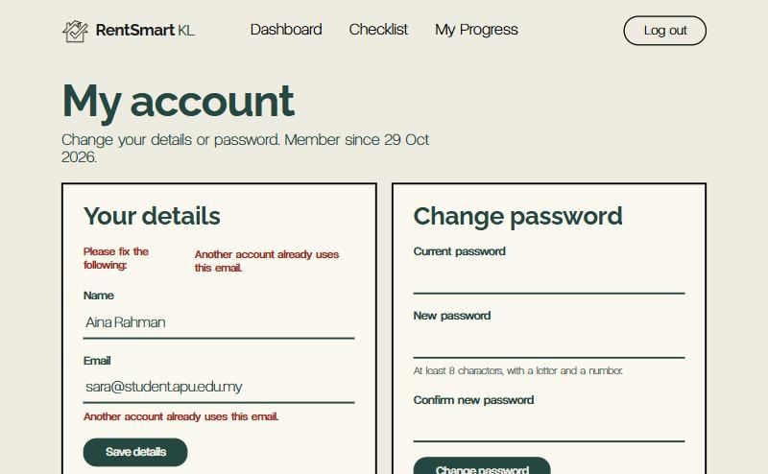
Figure 22: CustomValidator (server side): "Another account already uses this email."
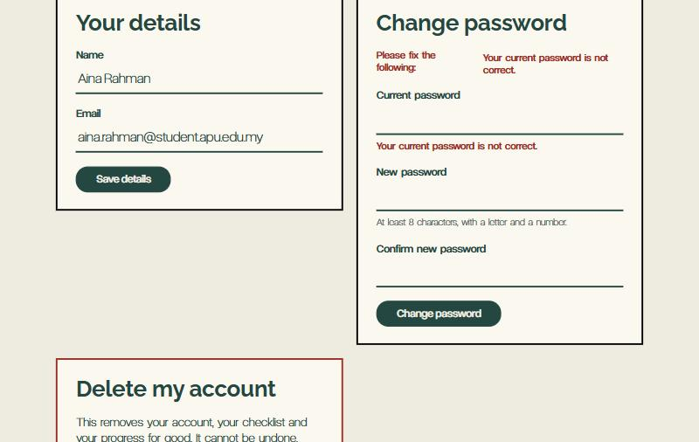
Figure 23: CustomValidator (server side): "Your current password is not correct."
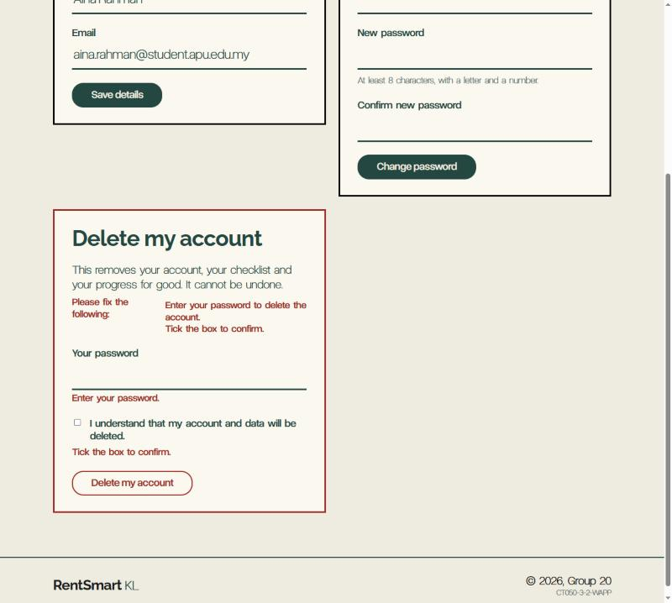
Figure 24: Delete card: password required and the "I understand" box must be ticked

4.9 CSS usage
The Member pages make a full use of all three types of CSS that were mentioned in the brief: external, internal and inline. They share the same class names as the rest of the website, which makes them consistent with it.
Type | Where it is used | Example
External | css/site.css, linked once in Site.Master | Shared classes such as btn, page-title, cl-list, data-table, stage-bar
Internal | A <style> block at the top of each Member page | Lesson View: .cp-options lays out the answer buttons. My Progress: .progress-table column widths
Inline | style="..." on single elements | The progress bar's box count, which comes from the database

Internal CSS example (Lesson View).
The present rules are applicable only within the current page, which is why no common stylesheet is updated.
.cp-options { list-style: none; padding: 0; margin: 0;
display: flex; flex-direction: column; gap: .6em; }
.lesson-video { aspect-ratio: 16 / 9; height: auto; background: #000; }
Inline CSS example (progress bar). The code writes the number of boxes to the style of the element, as it is only determined when the number of lessons is calculated.
html.AppendFormat(
"<div class=\"{0}\" style=\"--n:{1}; grid-template-columns:repeat({1}, minmax(0, 1fr))\" ...>",
cssClass, total, done);
When there are 7 lessons, the result is: style="--n:7; grid-template-columns:repeat(7, minmax(0, 1fr))", which is why there is one box for every lesson.

4.10 Testing
All 31 test cases were executed successfully in Windows (IIS Express, local database): tests 1-24 were conducted on the 16th and 17th of October 2026 right after Ahmed's theme was merged, while tests 25-31 were conducted on the 28th and 29th of October 2026 after the main branch (seed data, Status column and RedFlag column) was merged. Testing revealed three bugs that were fixed: some of the text including the < character crashed the checklist and ended up bringing an ASP.NET error page, a very long item displayed the error message twice, and the old success message occurred in My Account underneath the new error message.
# | Page | Test | Expected result | Result
1 | All Member pages | Open each page while logged out | Sent to the Login page | Pass
2 | All Member pages | Log out, then press Back | Sent to the Login page, no cached page | Pass
3 | Dashboard | Log in as a member | Greeting by name, stage count, next lesson, checklist preview | Pass
4 | Lesson View | Open ?id=abc and ?id=99999 | Opens the member's next unfinished lesson, no error | Pass
5 | Lesson View | Check my answers with nothing chosen | "Pick an answer for this question." | Pass
6 | Lesson View | Wrong answer, then right answer | "Not quite", then "Correct" and the stage marked done | Pass
7 | Lesson View | Lesson with no questions: Mark this stage as done | Stage saved as done with today's date | Pass
8 | Checklist | Add the starter list | Five items appear | Pass
9 | Checklist | Add an empty item, then a 2-letter item | Required and length messages | Pass
10 | Checklist | Add 150 characters with browser checks switched off | Server refuses it, one message shown | Pass (after fix)
11 | Checklist | Add Check <b>bold</b> & "quotes" | Saved and shown as plain text, no HTML runs | Pass (after fix)
12 | Checklist | Edit an item to 2 letters, then to valid text | Error, then "Item updated." | Pass
13 | Checklist | Tick, untick and delete an item | Count updates; delete asks first | Pass
14 | My Progress | Finish two stages | Two rows Done with dates; next stage Up next | Pass
15 | My Progress | Narrow screen | Table turns into cards, ✓ shown for done stages | Pass (after fix)
16 | My Account | Empty name and a bad email | Summary lists both errors | Pass
17 | My Account | Name <script>, or one letter | Name rule message | Pass
18 | My Account | Email of another account (in capitals) | "Another account already uses this email." | Pass
19 | My Account | Save a new name | "Your details were saved."; Dashboard shows the new name | Pass
20 | My Account | Weak, mismatched or unchanged new password | Strength, "do not match" or "must be different" message | Pass
21 | My Account | Wrong current password | "Your current password is not correct." | Pass
22 | My Account | Change the password, log out, log in | Old password refused, new password works | Pass
23 | My Account | Delete without the tick, then with a wrong password | "Tick the box to confirm.", then "The password is not correct." | Pass
24 | My Account | Delete an account that has checklist items and progress | Account removed, logged out, cannot log in again | Pass

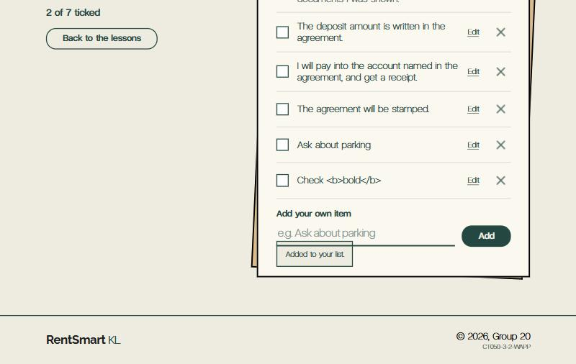
Figure 25: An item typed with HTML bold tags is shown as plain text, so no HTML runs (test 11)
Tests for the lesson Status update (October). These include the changes that took place when Status and RedFlag were incorporated into the Lessons table. These were executed on the merged code, with the logged-on user being the seeded member (sara@student.apu.edu.my), while tests 28 and 29 were carried out with the logged-in seed administrator.
# | Page | Test | Expected result | Result
25 | Dashboard, My Progress | Set one lesson to draft in the database | That stage disappears from the journey, the progress bar and the table; the total goes down by one | Pass
26 | Lesson View | Open the draft lesson's ?id= directly | Opens the next unfinished published lesson instead | Pass
27 | Lesson View | Open a lesson whose RedFlag is filled in, then one where it is empty | Red-flag box shown with that text; no box on the second | Pass
28 | All Member pages | Log in as admin and click Member view | Member Dashboard opens with the same published lessons a member sees | Pass
29 | My Account | As admin in Member view, try to delete the account | "Admin accounts cannot be deleted here."; account kept | Pass
30 | Lesson View | Lesson whose RedFlag text starts with a small letter | Shown in the box starting with a capital letter | Pass
31 | My Account | Save details, then save again with another account's email | Only the new error is shown; the old "saved" message is cleared | Pass (after fix)

5. User Guidance: using the Member area
The journey shows Aina, during the login process through the end of a stage and also creating her checklist. It can be seen that in the process of Aina’s journey, a screenshot has been captured for each step she went through in the specified period of 29th October 2026.
- Log on. Aina has inserted her email and password in the Login field and proceeded to the next stage. As it is a member’s role, she is taken directly to her dashboard.
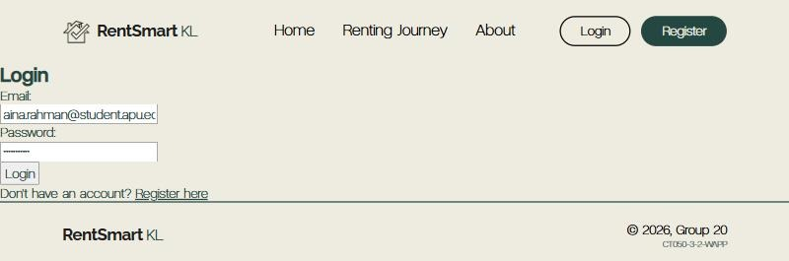
Figure 26: Login page with Aina's email and password filled in
- View Dashboard. Aina is welcomed by her name on the Dashboard which also provides her with data concerning the stages she has gone through and the next one she has. The dashboard includes a list of activities, subdividing them into Done, Up Next and Not started stages.
Figure 27: Member Dashboard
- Open the next lesson. Aina clicks on the Continue lesson option. The lesson comes with a list of all the stages present on the left side, the lesson text (with the video or picture if the lesson contains one), the red-flag box and the checkpoint at the bottom.
Figure 28: Lesson View, top of the page
- Try the checkpoint without answering. If Aina decides to click on Check my answers without selecting an option, the page then tells her to select an answer first.
Figure 29: "Pick an answer for this question."
- Answer wrongly, then correctly. An incorrect answer is represented as “Not quite” which means Aina can try again. When all answers are correct, the page shows that the stage is complete and it now says Done in the list on the left-hand side.
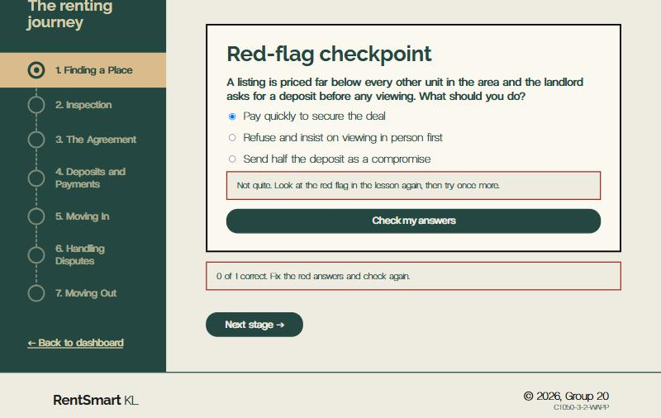
Figure 30: "Not quite" on a wrong answer, with "0 of 1 correct"
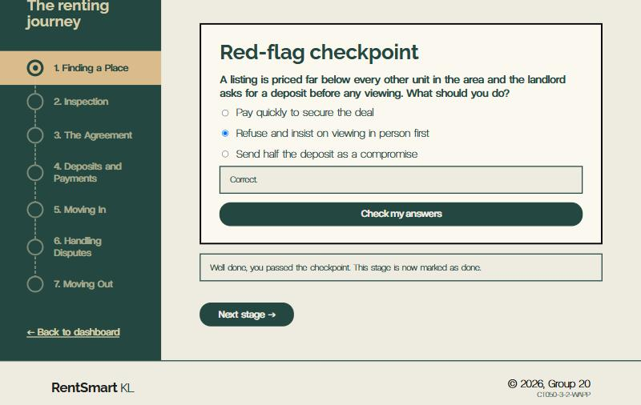
Figure 31: "Correct" and "Well done, you passed", with the stage now Done
- Check her progress. In the menu, Aina selects the option “My Progress.” The table demonstrates the stage she has achieved so far with the date being today. In addition, there is a Continue link leading to the next stage.
Figure 32: My Progress table
- Start the checklist. Then, Aina proceeds to the Checklist. As her list is blank, she hits the button that adds all the items to her list. This brings five standard items.
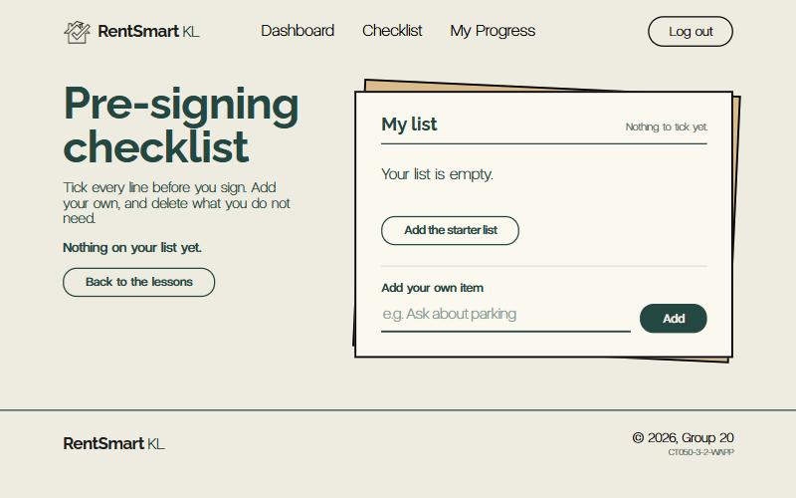
Figure 33: Empty checklist with the "Add the starter list" button
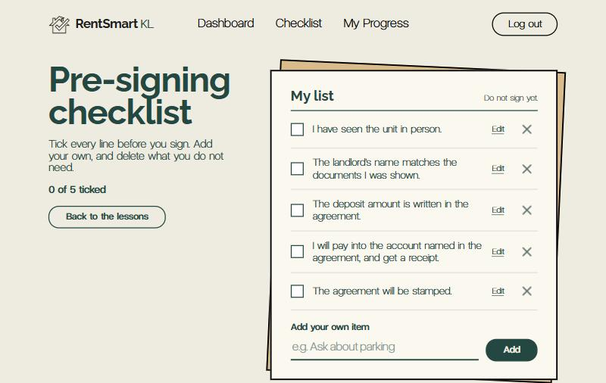
Figure 34: Checklist with the five starter items
- Add her own item. She puts the phrase “Inquire about parking” and hits Add. If Aina tries to hit the Add button leaving the box blank, she receives a message.
Figure 35: "Type an item first."
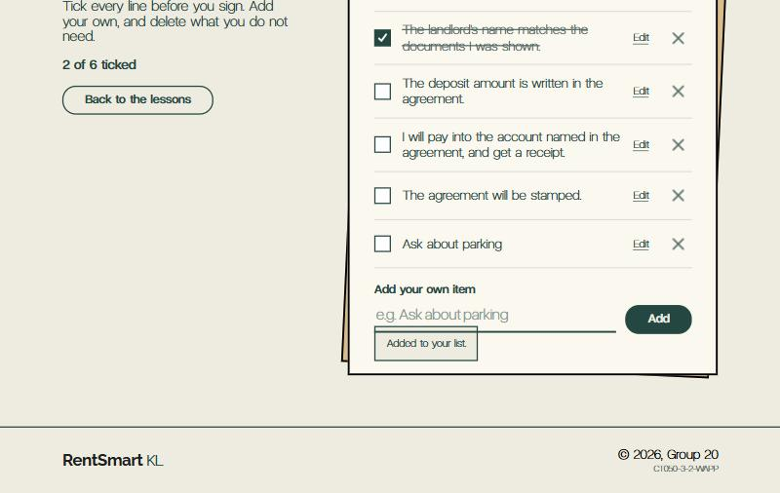
Figure 36: The new item at the bottom of the list, with "Added to your list."
- Tick and delete items. Next, Aina ticks and crosses out with a click. If she clicks again, the item will be unticked. The statement at the top indicates how many of the items have been ticked, e.g., “2 of 5 items ticked.” One can confirm their wish to delete the item by clicking on the X next to the item.
Figure 37: Ticked items and the updated count
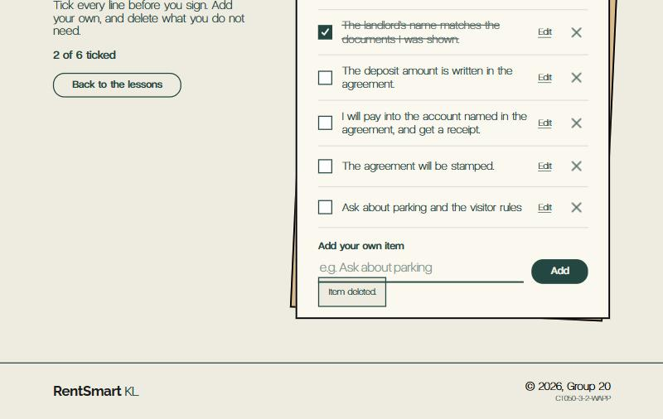
Figure 38: After confirming the pop-up: the item is gone and the page says "Item deleted."
- Edit an item. Aina clicks Edit next to “Inquire about parking” and changes it to "Inquire about parking and visitor rules" and presses the Save button. The list now shows this text and the message “Item is updated.”
Figure 39: The Edit box with Save and Cancel
- Manage her account. After accessing the dashboard, Aina navigates to My account. There, she alters her name and saves the changes. Following this, she also changes her password; when the new passwords entered are different, the system highlights the issue; when they match, the system confirms this change and allows the user to log in next time with the new password.
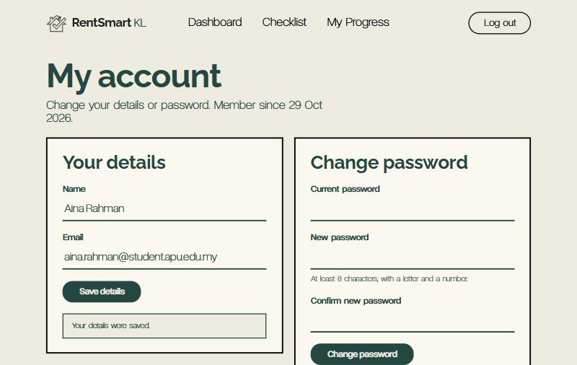
Figure 40: "Your details were saved."
Figure 41: "The two new passwords do not match." in the error summary
- Log out. After making sure everything was performed correctly, Aina clicks on Log out. In case she tries to access a Member page directly or clicks Back, she is redirected to the Login page.
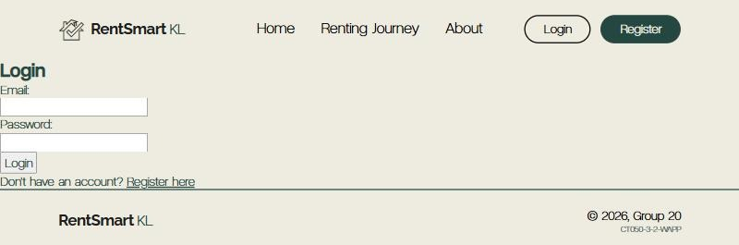
Figure 42: Login page shown after opening /Member/Dashboard while logged out

6. Conclusion

6.1 Summary
After signing in, the Member module provides student renters with all the necessary information, such as a dashboard that shows them what stage they are at, a total of seven lessons, a red flag box, a checkpoint for each stage, information about their progress, their own pre-signing checklist, etc. All five Member module pages read from and write to the common database, perform all the four operations, validate any form on the browser and the server, and only display the associated member's personal data.

6.2 Lessons learned
- It is wise to write common code once. By coding the login check and the journey request in MemberHelper.cs only one change (the publish-only filter) lets the changes be applied to Dashboard, Lesson View, and My Progress simultaneously.
- The browser can be unreliable. Client-side validation enhances UX, but the server checks every query, and each UPDATE and DELETE includes AND UserID, so even if ID has been changed in the page, it cannot reach another user's data.
- Encode what the user has typed in. Testing demonstrated that the text containing < crashed the checklist. Therefore, it is feasible to let the input and HTML encode it in the display.
- Teamwork matters. Working on a separate branch of Git, getting approval of the database owner for every change made to the database rather than modifying tables directly helped to avoid breaking the module of other team members.
- Testing must be user-based. Trying different actions on the website helped to find three bugs that could not be discovered otherwise.
- Three of the bugs were only found by trying real actions on the running site, such as failing a save straight after a successful one.

6.3 Future enhancements
- Passwords should be saved in the form of salted hashes instead of plain text, and should be implemented across the Register, Login, and My Account, all of which make use of the Users table.
- A certificate of accomplishment may be issued upon completion of seven stages.
- A member should be able to download or print the pre-signing checklist such that they may have it when going for a viewing.
- Should update all attempts and scores so that the members are aware of the most common mistakes made.
- Lessons can also be delivered in Bahasa Melayu.

7. References
Microsoft. (n.d.). CA3001: Review code for SQL injection vulnerabilities. Microsoft Learn. https://learn.microsoft.com/en-us/dotnet/fundamentals/code-analysis/quality-rules/ca3001
Microsoft. (n.d.). SqlTransaction class (System.Data.SqlClient). Microsoft Learn. https://learn.microsoft.com/en-us/dotnet/api/system.data.sqlclient.sqltransaction
Microsoft. (n.d.). Validating ASP.NET server controls. Microsoft Learn. https://learn.microsoft.com/en-us/previous-versions/dotnet/articles/aa479013(v=msdn.10)
OWASP Foundation. (n.d.). Cross site scripting prevention cheat sheet. OWASP Cheat Sheet Series. https://cheatsheetseries.owasp.org/cheatsheets/Cross_Site_Scripting_Prevention_Cheat_Sheet.html
OWASP Foundation. (n.d.). SQL injection prevention cheat sheet. OWASP Cheat Sheet Series. https://cheatsheetseries.owasp.org/cheatsheets/SQL_Injection_Prevention_Cheat_Sheet.html

